**TBD – Programmers:**

**Project title:**

* D&D character sheet
* DDCS
* D20
* D&D players aide
* D&D players journal
* Literally no clue so we’ll put a pin in that….

**Project logo:**

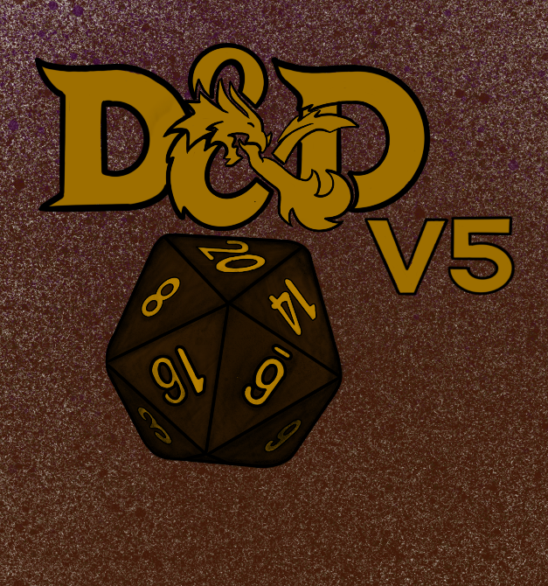

Color Scheme:

* or or or or

I like green and/or brown, earthy colors for the color scheme. -CS

**Home:**



.

.

.

Legolas

Elf Ranger Lvl 5

Harry Potter

Human Wizard Lvl 1

Shrek

Ogre Barbarian lvl9

Create New

1.)-> Create A Character

2.)-> Character Sheet

Side note:

Font: Engravers MT

Characters will be in a list

List will be ordered by date last used

Character Name should be followed by

Race

Class

Level

* All User clicks should transition to a new page.

Upon opening the app, make a call to the Business Logic layer for existing Character Sheets.

[2.)Once a selection is made, send index of selected Character sheet]

* Make call to service layer to retrieve array of Character Sheets ID’s.

[2.)Send index of selected Character sheet ID]

* Make call to data access layer for array of character sheets Id’s.

[2.)Move character sheet ID at index to the front of array and send updated array to DAL, request data for selected character sheet ID]

* Access array of character sheet ID’s

[2.)Save new array over old character sheet array]

Presentation

Business Logic

Service

Data Access

* Display CreateCharacter button, followed by list of character sheets.

[2.)Display character sheet starting on Gameplay page.]

* Organize character array for UI

[2.)Separate DO into relevant pages character sheet divisions (Story, Gameplay, Spells, Equipment)]

* Send corresponding Character Name, Race, Class, and Level in array to Business layer.

[2.)send entire DO for chosen character sheet to business layer]

* Send array of character sheets ID’s to Service Layer.

[2.)send DataObject correlating to first Character in character sheet array]

Side Note:

* Font: Imprint MT Shadow
* Allowing for characters starting at higher than level one will be difficult, low priority

1. **Create A Character**

Character Name: Legolas Thranduil

Race: Elf

Subrace: Wood Elf

Class: Ranger

Cancel

Next

Signifies a pull down with all relevant options loaded from the API

Exp: 0

Level: 1

* User clicks pull down for race

[2.)User chooses race]

* Make call to service layer to retrieve array of Race Options

[2.)Send id of selected race to Service layer]

* Make call to data access layer for array of available Races.

[2.) Send id of selected Race to Data access Layer ]

* Access array of Races

[2.)Find selected Race]

Presentation

Business Logic

Service

Data Access

* Display pull down list of available races

[2.)Wait for user to go to next page.]

* Arrange array of race names for pull down

[2.)Add race modifiers to current character sheets array of modifiers]

* Send list of races names to Business logic

[2.)send array of race modifiers to business layer]

* Send array of Races to service layer

[2.)send selected race to service layer]

Handbook rules for determining ability scores:

For each ability, roll four D6 dice and add together the three highest dice. Assign that roll to an ability and repeat.

-or-

Assign 15, 14, 13, 12, 10, 8 to stats of your choice.

(this can be a pop-up for new players)

Auto-Generate could automatically insert the handbook suggestions for race, or be a random dispersement of the std. 15, 14, 13, 12, 10, 8

?

Strength

Dexterity

Constitution

Intelligence

Wisdom

Charisma

Back

Next

Auto-Generate

Side Note:

* Font: Calibri (body)
* There could be a check for the sum of all stats to see if they are reasonable for a lvl 1 player, low priority
* Upon pressing next, send user input and correlating ability to business layer
* put ability scores in a new array (one array for mods, one array for pure ability scores)
* Add array of ability scores to new character data object.

Presentation

Business Logic

Service

Data Access

* Display Ability score confirmation page
* Apply mods from mod array to ability scores and send to UI

Strength

Dexterity

Constitution

Intelligence

Wisdom

Charisma

Back

Confirm

Page will be a simple confirm or go back.

It will display the ability scores from the previous step with the addition of racial increases, along with the algorithm calculated modifiers

Should provide a list of Race and Class approved options from which you can select. Loaded from Api and the a simple bubble pick.

Saving Throws

Skills

Back

Confirm

Next

Back

Background: Ranger 

______________________________________________________________________________________________________________________________________________________________________________________________________________________________________________________________________________________________________________________

Page will be a simple confirm or go back.

It will display the ability scores from the previous step with the addition of racial increases, along with the algorithm calculated modifiers

Alignment: Chaotic Good

**Name: Legolas Thranduil**

Age : 351

Weight: 120

Height: 6’

:

Eyes: Green

Hair: silver

Skin: pale

:

Name, type, calc modifier, price

Weapons



Game rules dictate weapons are typically either inherited from you race and class choices or purchased from starting gold.

We will leave it open to abuse by the user but list gold next to the weapon so if they wanted to follow rules they could. (our api does not list starter weapons for race or class)

All weapons will come from the API, low priority is adding a custom option.

Repeat for armor and other.

Back

Back

**Name: Legolas Thranduil**

**2.)Character Sheet**



Side Note:

* Font: Bahnschrift Condensed
* Page should scroll to show all features
* Ideally this page holds all the “storyline characteristics” and is not needed frequently. These characteristics will remain relatively static for most players.
* Some of these may need to be **uneditable,** as they will take strings from race/ class/ background, as presets.

Background:

[Shrek](https://en.wikipedia.org/wiki/Shrek_(character)), a mean and highly territorial green [ogre](https://en.wikipedia.org/wiki/Ogre) who loves the solitude of his swamp, finds his life interrupted when countless fairytale creatures are exiled there by the fairytale-hating and vertically-challenged [Lord Farquaad](https://en.wikipedia.org/wiki/Lord_Farquaad) of Duloc. Angered, he decides to ask Farquaad to exile them elsewhere. Shrek brings along a talking [Donkey](https://en.wikipedia.org/wiki/Donkey_(Shrek)), who is the only  fairytale creature willing to guide him to Duloc. 

Bonds:

____________________________________________________________

Flaws:

____________________________________________________________

Allies & Organizations:

____________________________________________________________

Background: Outlander

[Shrek](https://en.wikipedia.org/wiki/Shrek_(character)), a mean and highly territorial green [ogre](https://en.wikipedia.org/wiki/Ogre) who loves the solitude of his swamp, finds his life interrupted 

Features & Traits:

____________________________________________________________

Other Proficiencies & Languages:

____________________________________________________________

Personality Traits:

____________________________________________________________

Ideals:

____________________________________________________________

Alignment: Chaotic Good

Age: 45

Weight: 370

Height: 7’

:

Eyes: Green

Hair: none

Skin: Green

:

Name: Shrek

Background:

[Shrek](https://en.wikipedia.org/wiki/Shrek_(character)), a mean and highly territorial green [ogre](https://en.wikipedia.org/wiki/Ogre) who loves the solitude of his swamp, finds his life interrupted when countless fairytale creatures are exiled there by the fairytale-hating and vertically-challenged [Lord Farquaad](https://en.wikipedia.org/wiki/Lord_Farquaad) of Duloc. Angered, he decides to ask Farquaad to exile them elsewhere. Shrek brings along a talking [Donkey](https://en.wikipedia.org/wiki/Donkey_(Shrek)), who is the only  fairytale creature willing to guide him to Duloc.

* User Clicks on , and the full string is shown in pop-up window. (Full string should already be loaded) User clicks, and the string is made editable to the user. After New string is sent to Business Logic Layer
* New string is taken from UI and sent to the service layer.
* New string is taken from Business Logic and sent to Data Access Layer to be saved.
* New string is saved to current Character sheet.

Presentation

Business Logic

Service

Data Access

* String has been updated user can finish viewing then click , to return to full character sheet.
* The window will be updated to return to , the string will no longer be editable.
* String has been updated, no information needs to be returned as a copy of new string is already present.
* String has been updated

\

Charisma

**13**

**+1**

Intelligence

**15**

**+2**

Constitution

**14**

**+2**

**2a.)?**

**2b.)?**

Modifiers/Saving Throws: the two will just be a toggle and the circles below the stats will hold the values for whichever is highlighted, because saving room…

Clicking on this will pull up the list of Proficiencies, as apposed to swiping to the other page

A pop up that lets you select and deselect the dots…

Idk how this works yet, perhaps a pop up that allows for switching between normal and temporary hit points and a way to take damage

Level-Up

Rest

Turn Based-Actions

**+3**

10

**+1**

Skills

Modifiers

Saving Throws

+2

Passive Wisdom

Proficiency Bonus

Wisdom

**10**

**+0**

Dexterity

**12**

**+1**

Strength

**8**

**-1**

Class: Wizard

Background: Sage

Armor Class

Initiative

Speed

**30 ft**

Death Saves

Successes

**1-D6**

Failures



Current Hit Points

Hit Dice

Level: 1

Exp: 0

:

Race: Human

Sub-Race: none nnoneWizard

:

Side Note:

* Font: Copperplate Gothic Light
* The dependencies on here are gonna be insane 😊
* Most data will be derived, or dynamic

Name: Harry Potter

* User clicks on , and a Death Saves pop-up is shown (possibly with radio like buttons allowing you to select the number). When the user exits the pop-up, the new value is sent to the Business Logic Layer
* Value is taken from the UI and sent to the service layer
* Value being sent to the Data Access Layer to be saved
* New Death Saves data is saved to the character sheet

Presentation

Business Logic

Service

Data Access

* The graphics on the character sheet will change to reflect what the user selected
* The screen will return to the full character sheet and the pop-up will disappear
* If character dies, new info will have to be passed?
* Values in the Data Access layer have been updated and will sent it back through (Not sure what happens when you get to 3 or go past)



Not sure Attacks needs to be here, since your attacks depends on your weapon and this attack information is usually found with the weapon of choice.

Having text boxes for Class level, Spell attack bonus (+7 for instance), and the DC is crucial. Not sure what spell casting ability is here or if it’s needed.

Maybe this could be a page just for spells?

There will be a lot throughout the game, a certain amount of cantrips (spells you do not need to prepare), 1st level, 2nd level spells… So I think just having spells here is fine.

-CS

Side Note:

* Font: Franklin Gothic Book
* Ideally we would add a weapon and that weapon would draw from appropriate modifiers
  + Add Weapons from a list of ones provided by api
  + Allow custom?
* Ideally spells would be added and pull from appropriate stats and modifiers.
* Apparently spells are complex and I do not fully understand them yet
  + Add Spells from a list of spells provided by api
  + Allow custom?

**Shortbow +7 10D6 +3 P**

**Shortbow +7 10D6 +3 P**

**Spells**



**SpellCasting Class:**

**SpellCasting Ability:**

**Spell Save DC:**

**Spell Attack Bonus:**

**Name Atk Bonus Damage/Type**

**Shortbow +7 10D6 +3 P**

**Attacks**

* User can select the + button from spells to choose from a list of spells or can type in their own spell.
* The spell that is selected sends the string to the service layer.
* String is sent from the BLL and is searched and called api, data is sent to the DAL
* New spells and related info are saved to the character sheet, add it to array of spells.

Presentation

Business Logic

Service

Data Access

* Display stats and spells on the UI.
* Window will be updated
* Send the spells name and stats to Business Logic layer
* Send new array of spells to the Service Layer



Not sure what the five ovals are for, the important stats I think of are proficiency, strength, wild shape (if any)



Other



Armor



Weapons



0 0 0 20 0

* User selects the + button of the and is prompted to enter the weapon name (or create a new one) from the handbook weapons. Clicks on one he/she wants to add.
* The item selected sends the string of the weapon to the service layer.
* String is taken from the Business Logic Layer and is searched in the API, data is sent to the data access layer
* New weapon ands stats of weapon are saved to the character sheet, add it to array of weapons

Presentation

Business Logic

Service

Data Access

* Display new weapon in the list of scrollable weapons in the UI.
* Send the weapons’ name and stats to Business Logic layer
* Send new array of weapons to the Service Layer